**Design Record**

**ENEL 453 - Lab 3**

***Group 12***

***Aaron Born, Bianca Berselli, Steven Ng***

RTL of top-level entity:

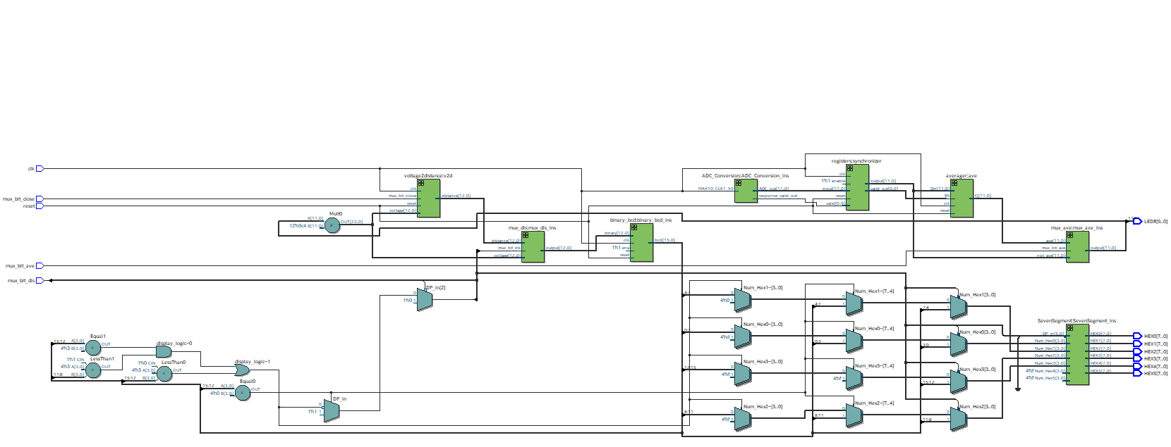

Testbench:

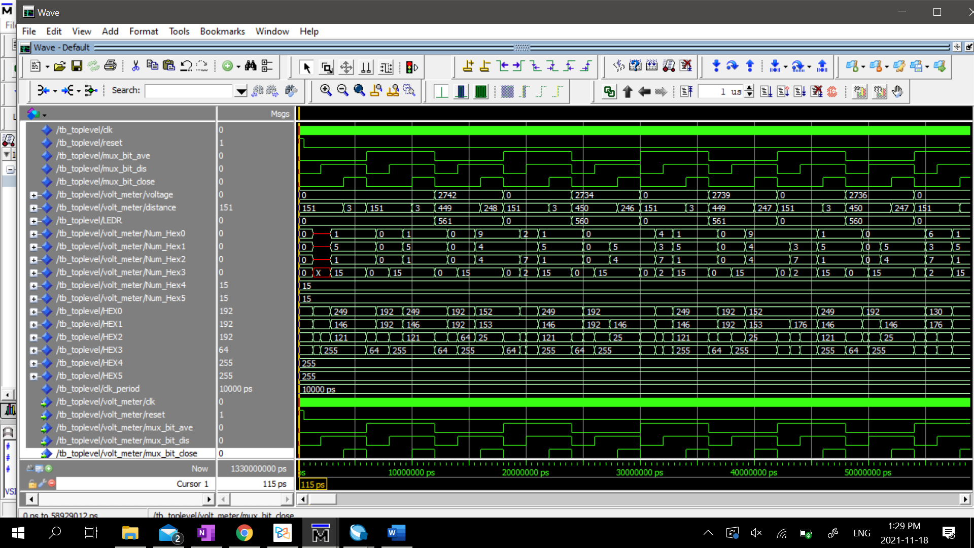

Timing Analysis:

